**Model Binding**

Model Binding is a feature of asp.net core that reads values from http requests and pass them as arguments to the action method.

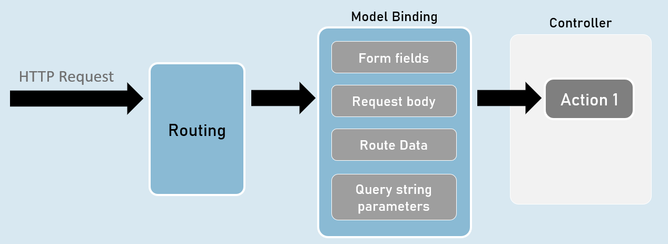

**QueryString vs RouteData**

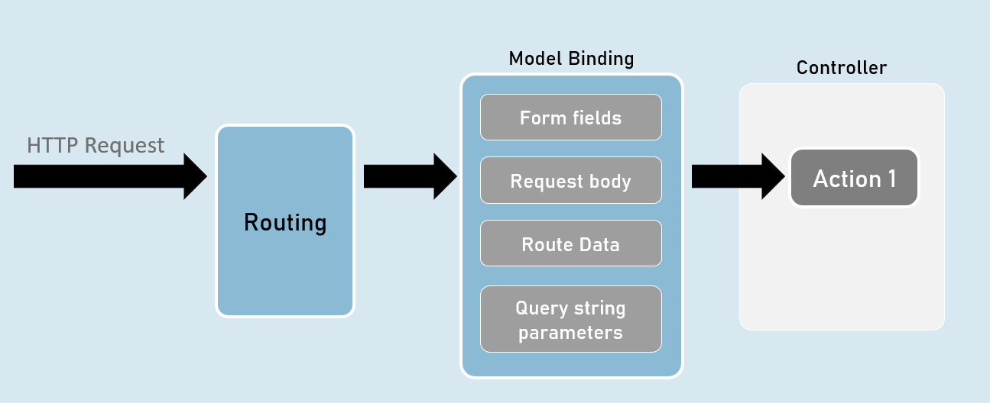

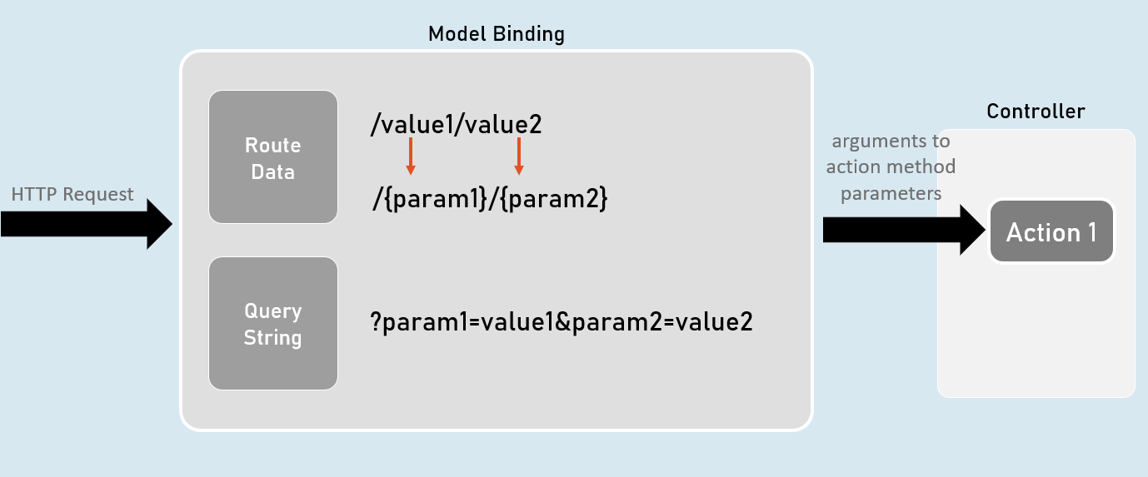

**[FromQuery] and [FromRoute]**

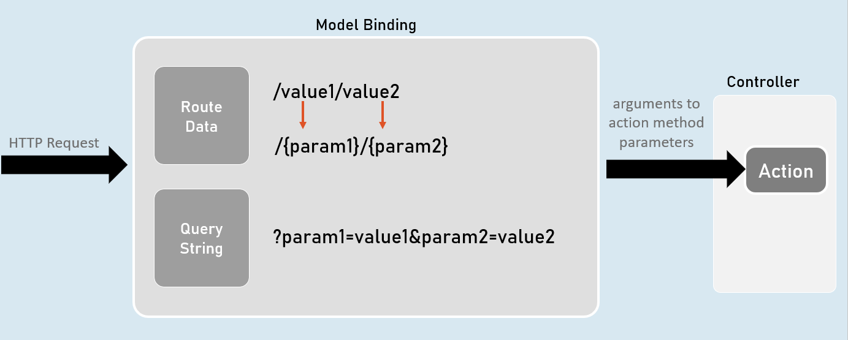

[FromQuery]

//gets the value from query string only

public IActionResult ActionMethodName( [FromQuery] type parameter)

{

}

[FromRoute]

//gets the value from route parameters only

public IActionResult ActionMethodName( [FromRoute] type parameter)

{

}

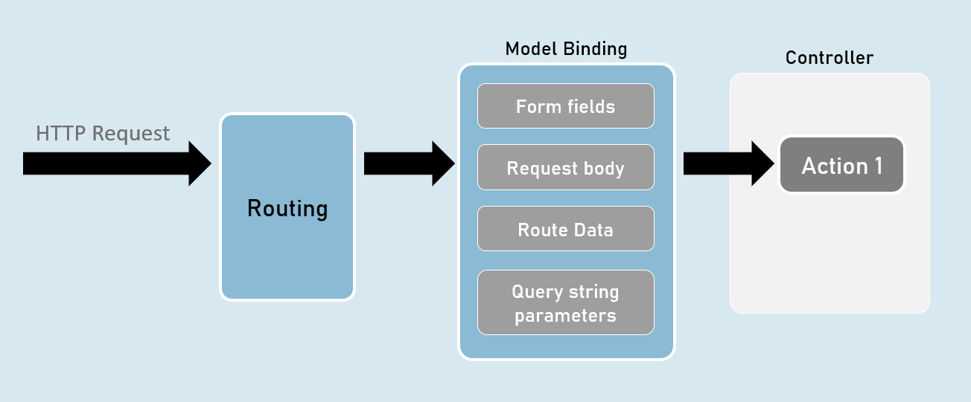

**Models**

Model is a class that represents structure of data (as properties) that you would like to receive from the request and/or send to the response.

Also known as POCO (Plain Old CLR Objects).

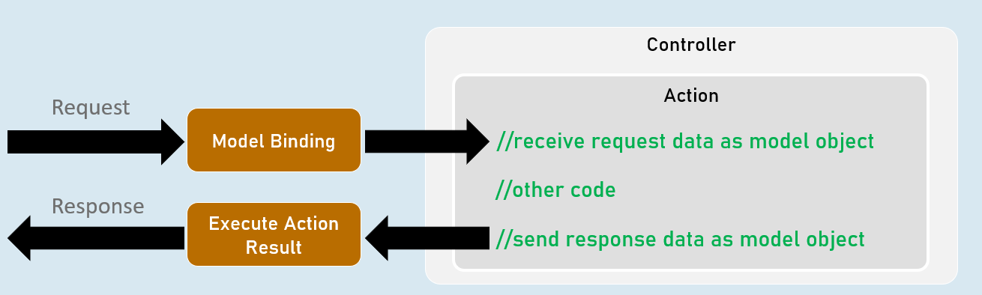

Model

class ClassName

{

public type PropertyName { get; set; }

}

**form-urlencoded and form-data**

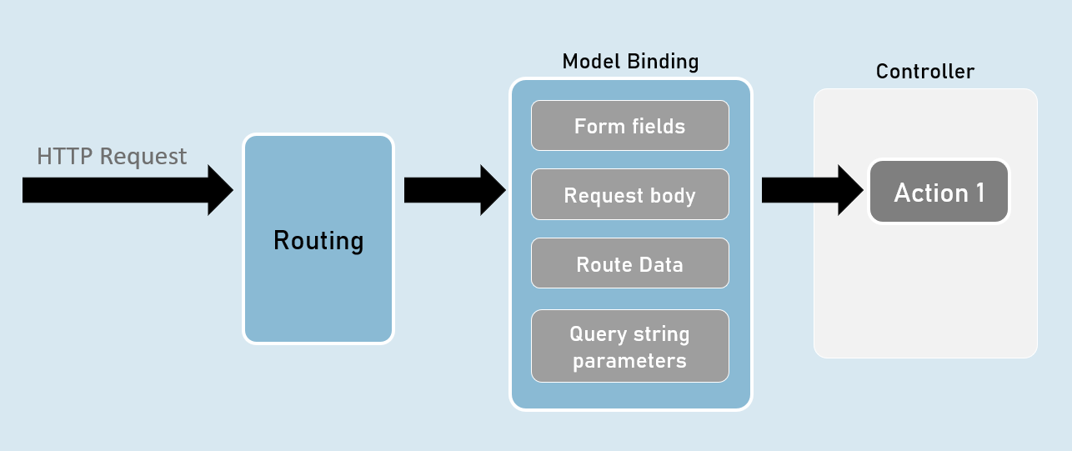

**form-urlencoded (default)**

**Request Headers**

Content-Type: application/x-www-form-urlencoded

**Request Body**

param1=value1&param2=value2

**form-data**

**Request Headers**

Content-Type: multipart/form-data

**Request Body**

--------------------------d74496d66958873e

Content-Disposition: form-data; name="param1"

value1

--------------------------d74496d66958873e

Content-Disposition: form-data; name="param2"

value2

**Model Validation**

class ClassName

{

[Attribute] //applies validation rule on this property

public type PropertyName { get; set; }

}

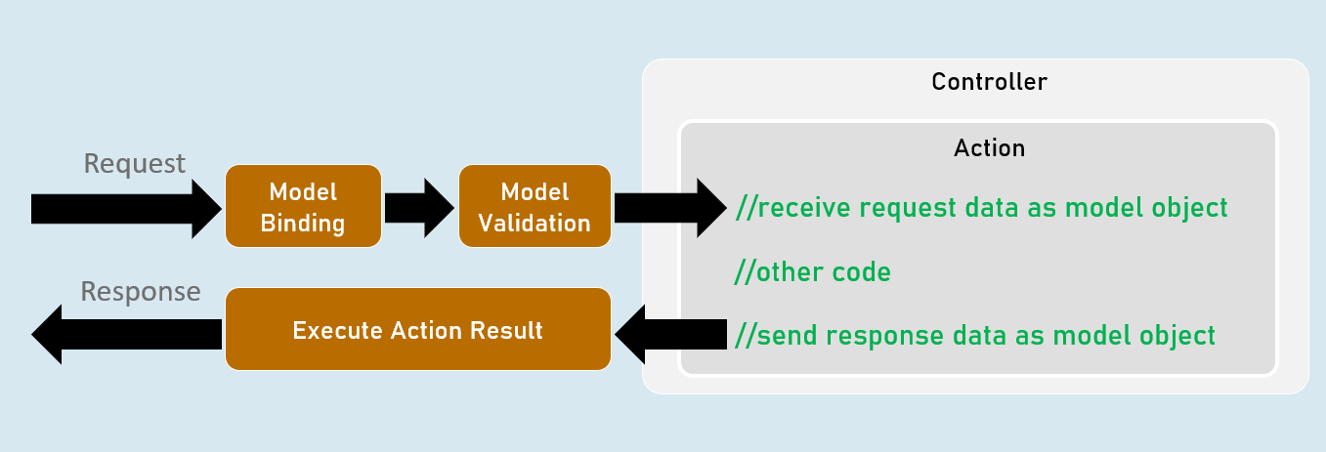

**ModelState**

**IsValid**

Specifies whether there is at least one validation error or not (true or false).

**Values**

Contains each model property value with corresponding "Errors" property that contains list of validation errors of that model property.

**ErrorCount**

Returns number of errors.

**Model Validation**

**[Required(ErrorMessage = "value")]**

Specifies that the property value is required (can't be blank or empty).

**[StringLength(int maximumLength, MinimumLength = value, ErrorMessage = "value")]**

Specifies minimum and maximum length (number of characters) allowed in the string.

**[Range(int minimum, int maximum, ErrorMessage = "value")]**

Specifies minimum and maximum numerical value allowed.

**[RegularExpression(string pattern, ErrorMessage = "value")]**

Specifies the valid pattern (regular expression).

**[EmailAddress(ErrorMessage = "value")]**

Specifies that the value should be a valid email address.

**[Phone(ErrorMessage = "value")]**

Specifies that the value should be a valid phone number).

Eg: (999)-999-9999 or 9876543210

**[Compare(string otherProperty, ErrorMessage = "value")]**

Specifies that the values of current property and other property should be same.

**[Url(ErrorMessage = "value")]**

Specifies that the value should be a valid url (website address).

Eg: http://www.example.com

**[ValidateNever]**

Specifies that the property should not be validated (excludes the property from model validation).

**Custom Validations**

class ClassName : ValidationAttribute

{

public override ValidationResult? IsValid(object? value, ValidationContext validationContext)

{

//return ValidationResult.Success;

//[or] return new ValidationResult("error message");

}

}

**ValidationAttribute**

* Base class for all validation attributes such as RequiredAttribute, RegularExpressionAttribute, RangeAttribute, StringLengthAttribute, CompareAttribute etc.
* Provides properties such as ErrorMessage & methods such as Validate(), IsValid() etc.

**ValidationContext**

* Acts as a parameter for "IsValid()" method of custom validation attribute classes.
* Provides properties such as ObjectType, ObjectInstance.

**Custom Validations with Multiple Properties**

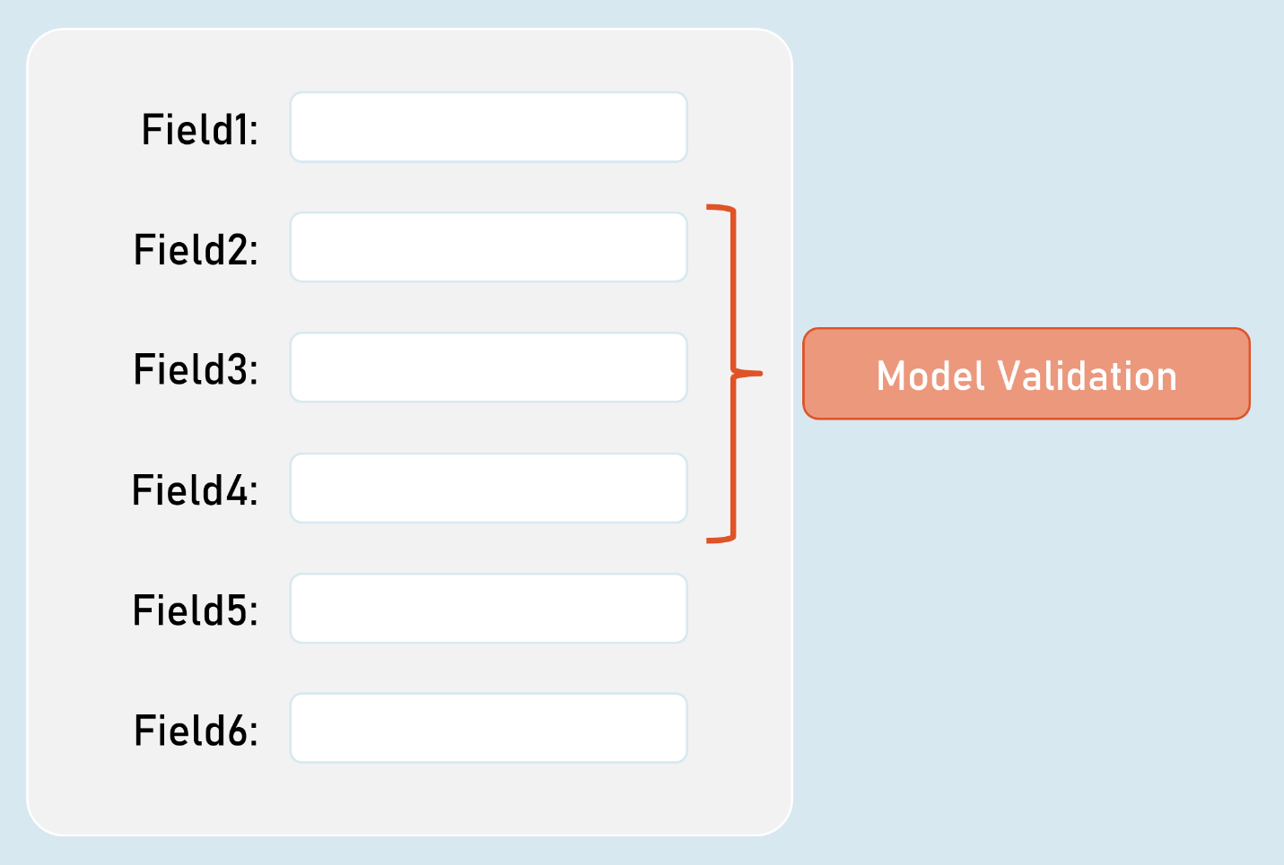

**IValidatableObject**

class ClassName : IValidatableObject

{

//model properties here

public IEnumerable<ValidationResult> Validate(ValidationContext validationContext)

{

if (condition)

{

yield return new ValidationResult("error message");

}

}

}

* Base class for model classes with validation.
* Provides a method called Validate() to define class level validation logic.
* The Validate() method executes after validating all property-level validations are executed; but doesn't execute if at least one property-level validations result error.

**ValidationContext**

* Acts as a parameter for "Validate()" method of model classes with IValidatableObject.
* Provides properties such as ObjectType, ObjectInstance.

**[Bind] and [BindNever]**

**[Bind]**

class ClassNameController

{

public IActionResult ActionMethodName( [Bind(nameof(ClassName.PropertyName), nameof(ClassName.PropertyName) )] ClassName parameterName)

{

}

}

* [Bind] attribute specifies that only the specified properties should be included in model binding.
* Prevents over-posting (post values into unexpected properties) especially in 'Create' scenarios.

**[BindNever]**

class ModelClassName

{

[BindNever]

public type PropertyName { get; set; }

}

* [BindNever] attribute specifies that the specified property should NOT be included in model binding.
* Useful when you have fewer properties to eliminate from model binding.

**[FromBody]**

//enables the input formatters to read data from request body (as JSON or XML or custom) only

public IActionResult ActionMethodName( [FromBody] type parameter)

{

}

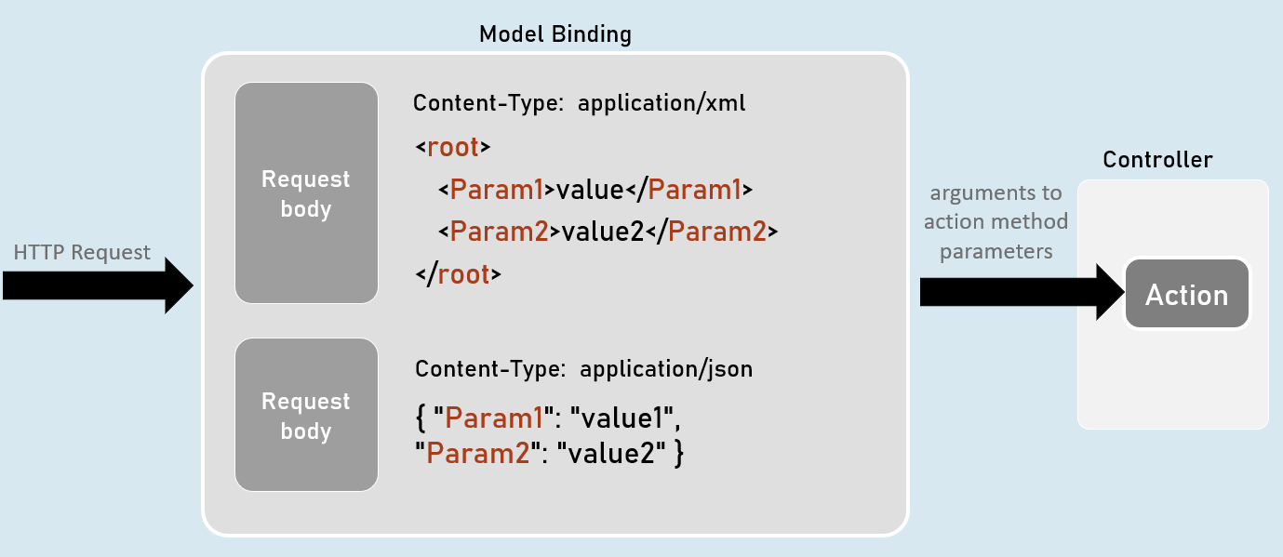

**Input Formatters**

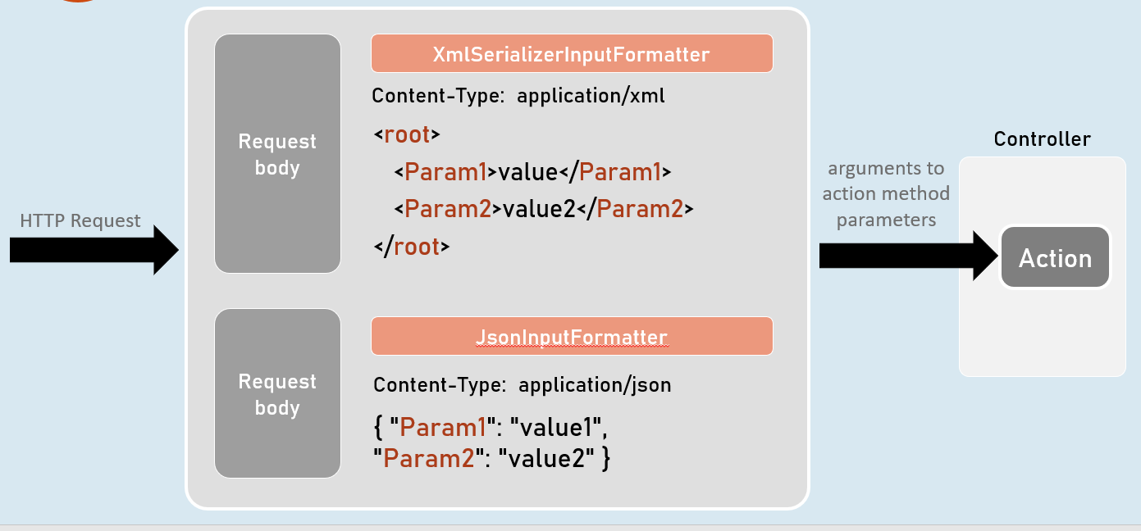

**Custom Model Binders**

**Custom Model Binder**

class ClassName : IModelBinder

{

public Task BindModelAsync(ModelBindingContext bindingContext)

{

//gets value from request

bindingContext.ValueProvider.GetValue("FirstName");

//returns model object after reading data from the request

bindingContext.Result = ModelBindingResult.Success(your_object);

}

}

**IModelBinder**

* Base interface for all custom model binders.
* Provides a method called BindModelAsync, to define logic for binding (reading) data from the request and creating a model object that has be received as parameter in the action method.

**ModelBindingContext**

* Acts as a parameter for "BindModelAsync()" method of custom model binder classes.
* Provides properties such as HttpContext, ModelState, ValueProvider, Result etc..

**Custom Model Binder Providers**

class ClassName : IModelBinderProvider

{

public IModelBinder GetBinder(ModelBinderProviderContext providerContext)

{

//returns type of custom model binder class to be invoked

return new BinderTypeModelBinder(typeof(YourModelBinderClassName));

}

}

**IModelBinderProvider**

* Base interface for all custom model binder providers.
* Provides a method called GetBinder, to return the type of custom model binder class.

**ModelBinderProviderContext**

* Acts as a parameter for "GetBinder()" method of custom model binder provider classes.
* Provides properties such as BindingInfo, Services etc.